PeriWatch System User/Authentication Requirements

Authentication
Depending on the steps involved, access to the SQL Server database server (Server/Instance) and the Reporting Server (if separate) is required. Although the deploying VM/PC does not need SSMS, connections to these database servers will be required by either of the following:
- Windows Authentication: The currently signed in user on the deploying VM/PC can connect to the database server and has permissions to install/upgrade.
- SQL Server Authentication: A valid LOGIN user and password with appropriate permissions.
Once the application is installed, it is common to have an AD account used by PeriGen support/operations users in order to login to the application for configuration, training and maintenance purposes.

PWS_ADMIN LOGIN
If a Windows Authenticated user does not have sufficient permissions, a PWS_ADMIN login with permissions could be used. Please work with the customer’s DBA to establish this login.

Permissions for Installation User
Ideally, the authenticated user should have temporary SYSADMIN permissions. This is especially useful for New Database installations as the following happens:
- Logins are created (PWT_USER, etc.)
- CREATE and ALTER DATABASE(s)
- An Assembly (CLR) file is added.
  - UTC_CLR.DLL
During the database creation step, the setup program must add an assembly file to handle the local date and time conversions based on time zone and daylight savings settings. After deployment, the file should appear in the following location:
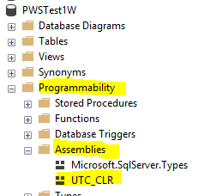

- CLR is Enabled
  - 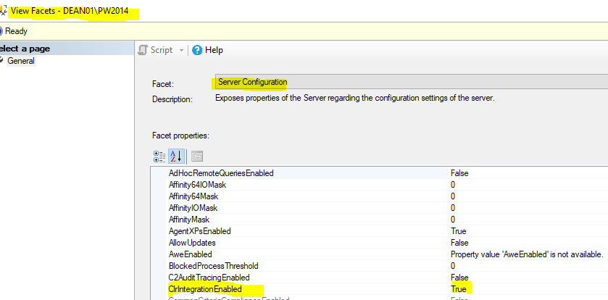
- SQL Agent Jobs created and managed (msdb database)
  - See note below regarding SQL Job ownership. *
- Reports deployed.
- Database Users are created (PWT_USER, etc. see further details below).

Permissions Summary
Login / User | Permissions / Roles / Notes
PWS_Admin (temporary install user, if used) | Temporary sysadmin to install and configure databases.
PWT_USER Login | Public*
PWT_USER User (Surveillance Databases) | db_datareader, db_datawriter, ProcExecuter*
PWTReportUser (local on Report server or domain) | Calls SSRS reports from App. Report folder permissions.
HUBReaderUser Login | Public*
HUBReaderUser User (Select Vigilance Databases) | Read Only permissions*
HUBUser Login | Public*
HUBUser User (Vigilance Databases) | db_datareader, db_datawriter, db_executor*
AD Auth User/Service Account | Used to query AD
IIS AuthenticationAppPool Service Account (should be the same master service account provided) | User context to run the PeriWatch IIS Services
* Created by default as part of the installer

SQL Job Ownership
Prior to SQL 2016, most SQL Agent jobs were created using the local default owner of NT AUTHORITY\SYSTEM. This local account contained the permissions necessary to call the SQL Agent Jobs related to the databases. With SQL 2016, this account was either disabled or not available by default, which caused errors with the job execution.

Presently, SQL Agent jobs are created with the default owner of SA. Some of our clients choose to disable SA which will cause an error during the installation. If this is case, PeriGen suggests the following:
- Temporarily enable the SA account.
- Complete the installation of the 3 SQL Jobs.
- Change the ownership of the jobs to an account supplied by the customer.
- Disable the SA account.

PeriWatch Vigilance Bundle

Database installation for this package can be done by a user with temporary SYSADMIN rights on the SQL server OR have the customer DBA install the scripts directly under their account.
As part of Software package installation DBSCHEMA permissions are required for the user running the software installation.
Following installation, only non-admin user access is required (see HUBUser account in the previous table).
For further details, please refer to the approved installation guides.

